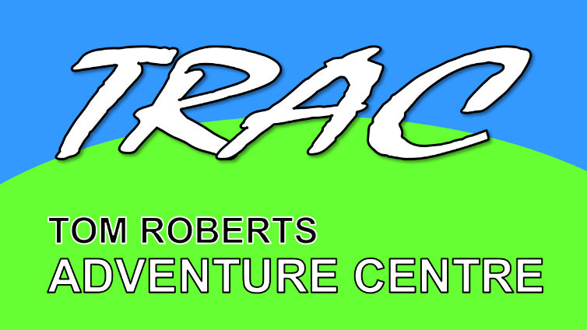
Tom Roberts Adventure Centre
Yates Farm, Malswick, Newent Gloucestershire, GL18 1HE
www.tracnewent.org.uk

TOM ROBERTS ADVENTURE CENTRE CODE OF CONDUCT

It is the responsibility of all Trustees Employees, Volunteers, Contractors or Official Visitors to Tom Roberts Adventure Centre (TRAC) to:

- Be aware of the contents of the TRAC Safeguarding Policy and the law as it applies to TRAC, and to conduct themselves within these guidelines and the law.
- Do not enter sleeping areas when groups are in residence, unless accompanied by a leader of the group.
- Keep physical contact with site users to a minimum and only use if absolutely necessary
- Do not take photographs of any groups using the centre unless written permission has been granted from both the centre manager and group leader.
- Never be on your own with a child or vulnerable adult – always make sure you are in full sight of others.
- Liaise with group leaders where possible if a child or vulnerable adult is upset, feels unwell or confides in you about anything. Encourage the child or vulnerable adult to engage with the visiting group leaders to deal with this rather than dealing with it yourself unless the issue involves leader or adult within the visiting group and the child or vulnerable adult does not feel able to approach their own group in which case it should be reported directly to the centre manager.
- Consider your behaviour and not engage in any behaviour that constitutes any form of abuse or bullying.
- Treat all people fairly and with respect and dignity and recognise the opinion of others.
- Be accountable for your actions and do not use unequal power relationships for your own benefit.
- Work with others in an open and participative way.
- Respect any position of trust and maintain appropriate boundaries with others.
- Exercise reasonable care in the course of your role to ensure the Health and Safety of yourself and others.
- Report any potential hazards or breakages to the centre manager.
- Follow the instructions of TRAC staff and Trustees and make them aware if you are unable to do so.
- Report any injuries to yourself or others to the centre manager.
- Refrain from smoking and taking of illegal drugs whilst on site.
- Never use language that could be considered to foul, vulgar or defamatory or could be considered to be sexual, racial or religious harassment.
- Conduct themselves in a manner that recognises the ethos of TRAC as laid out in the mission and vision statements.

